Create a simple cloud software application for Property Buying & Rental process (In Chennai city) using any Cloud Service Provider to demonstrate SaaS.
AIM
To design and deploy a simple Property Buying and Rental Management System for Chennai city using Zoho Creator as a cloud service provider and demonstrate the Software as a Service (SaaS) model, where users can access the application through a web browser without installing any software.

PROCEDURE
- Login to Zoho Creator using a valid Zoho account.
- Create a new application named Property Buying & Rental System (Chennai).
- Create a Property Details Form with fields such as Property Name, Location (Chennai areas), Property Type, Buying Price, Rental Price, and Availability Status.
- Create a Owner Details Form to store owner name, contact number, and email ID.
- Create a Customer Details Form with fields such as Customer Name, Mobile Number, Email ID, and Property Requirement (Buy/Rent).
- Create a Booking / Enquiry Form to capture customer interest in selected properties.
- Link the forms to maintain property, owner, and customer information.
- Configure user access permissions for buyers, renters, and admin.
- Publish the application to the cloud using Zoho Creator.
- Test the application by entering sample property buying and rental details.
Output
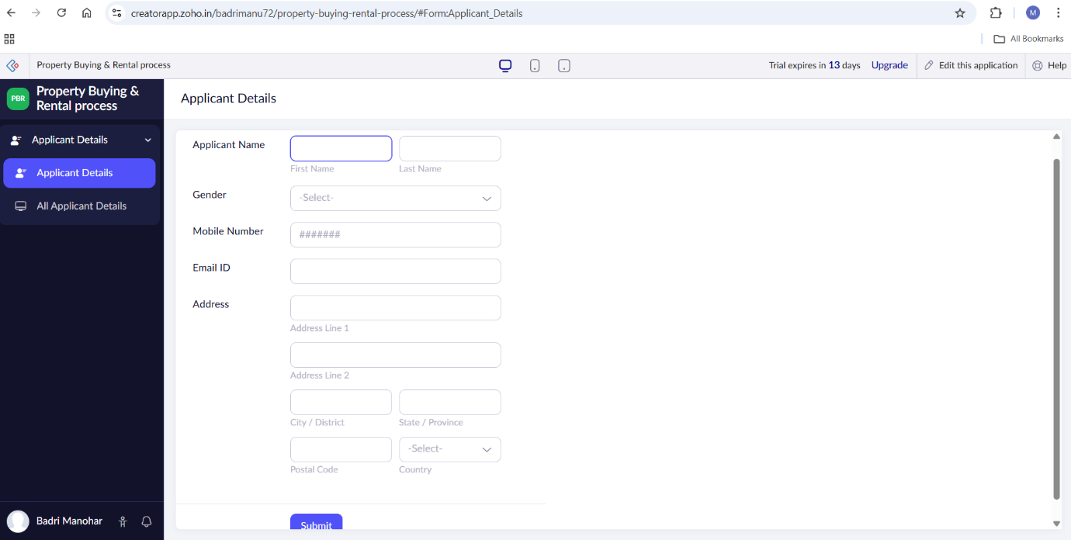
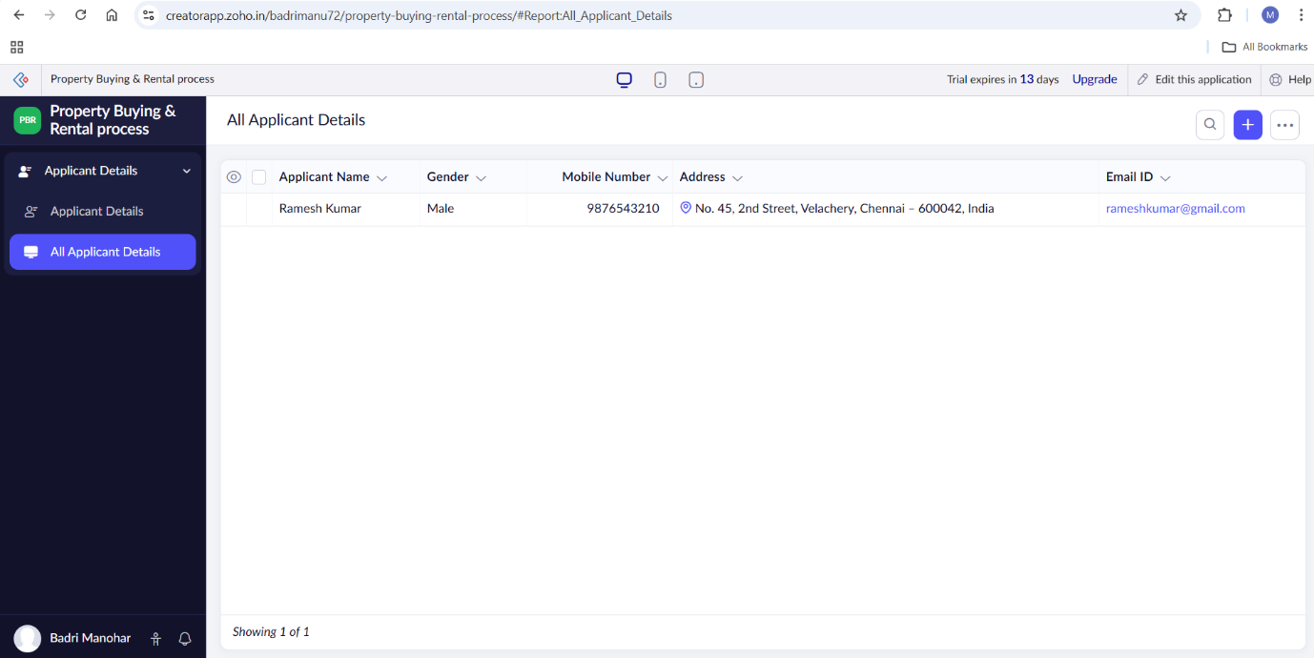
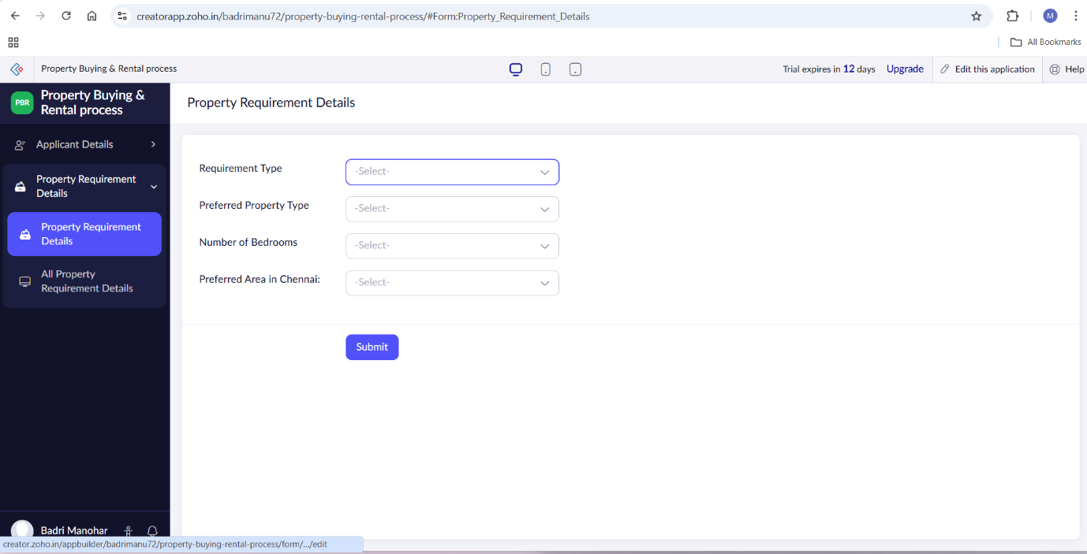
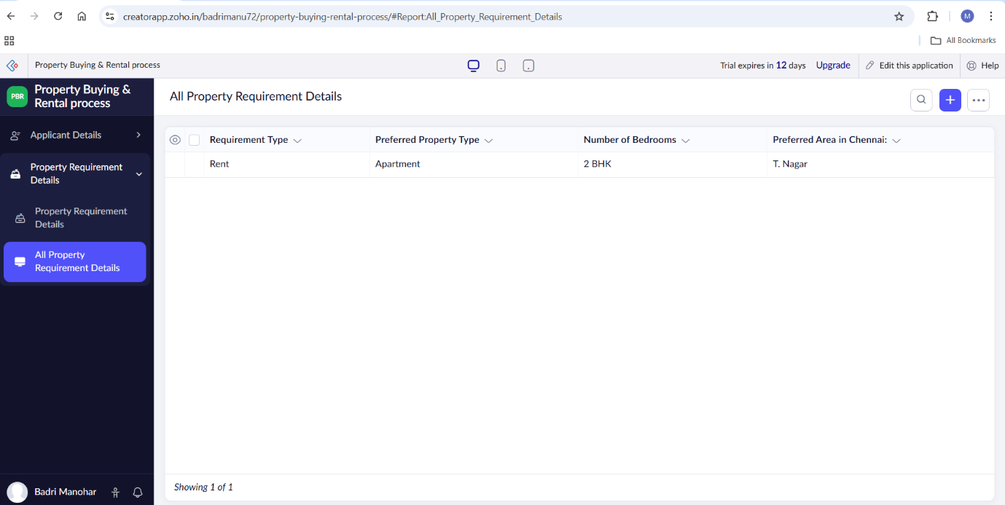

Result
A simple Property Buying and Rental System for Chennai city was successfully developed and deployed using Zoho Creator as a SaaS application. The system enables users to view property details, submit buying or rental enquiries, and manage property information online. The application can be accessed anytime and anywhere through a web browser without installing any software, thus demonstrating the Software as a Service (SaaS) model.

